Name ________________________________ AP Calculus
CW: Section 3.8 Review: Derivatives of Inverse Functions

Show all your work!

1.

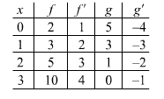

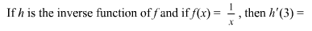
2.

3.

4.

5.

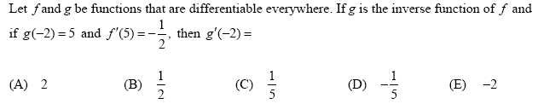
6.

$f(x)=x^{5}+x$$\frac{d}{\text{dx}}f^{−1}(x)$
7. Let . Find the value of at x = 2.

8. Find the derivative of the inverse of y = e^{x} at y = e.

9. Find the derivative of the inverse of y = x³ – 1 at y = 7.

$y=\frac{8}{x^{3}}$
10. Find the derivative of the inverse of at y = 1.

